Hunt Library Assignment

1. Does the library have your textbook? Maybe! The library has a Reserve Collection of faculty-selected materials that includes some textbooks. Reserve titles can be checked out for up to 3-hours. To see if the library has a textbook you need, go to the Hunt Library Website at <http://huntlibrary.erau.edu> , underneath “Quick Links” (toward the middle of the page), click the “Course Reserves” link and use the dropdown menus to see if we have your course’s textbook. It’s that easy!

1. What about electronic resources? From the Hunt Library home page, click on **Articles & Databases** in the left margin (next to the EAGLEsearch box), then link to **All Research Databases** under the EAGLEsearch box.

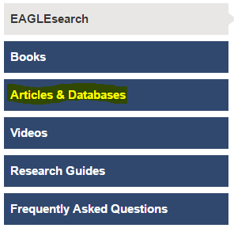 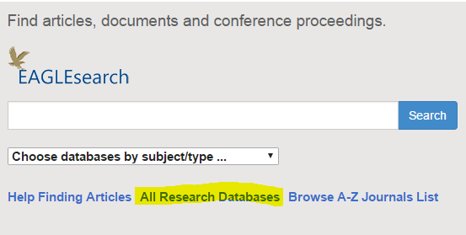

* + How many Research Databases does the Hunt Library have?

1. 1-3
2. 10-60
3. 100+
4. And some research help? Again, from the Hunt Library home page, click on **Research Guides** from the same menu as you did in the above question. Next, click the **Research Guides Home** link, and click into the **Aerospace Engineering** guide. Read the **About This Guide** section – how many different types of resources are covered in the guide?

1. Go visit the library. Find the leisure reading section (first shelves to your left as you walk in), pick out a book and take a selfie. If you want, put it up on a social media platform of your choice with the #erauhuntlibrary hashtag!